[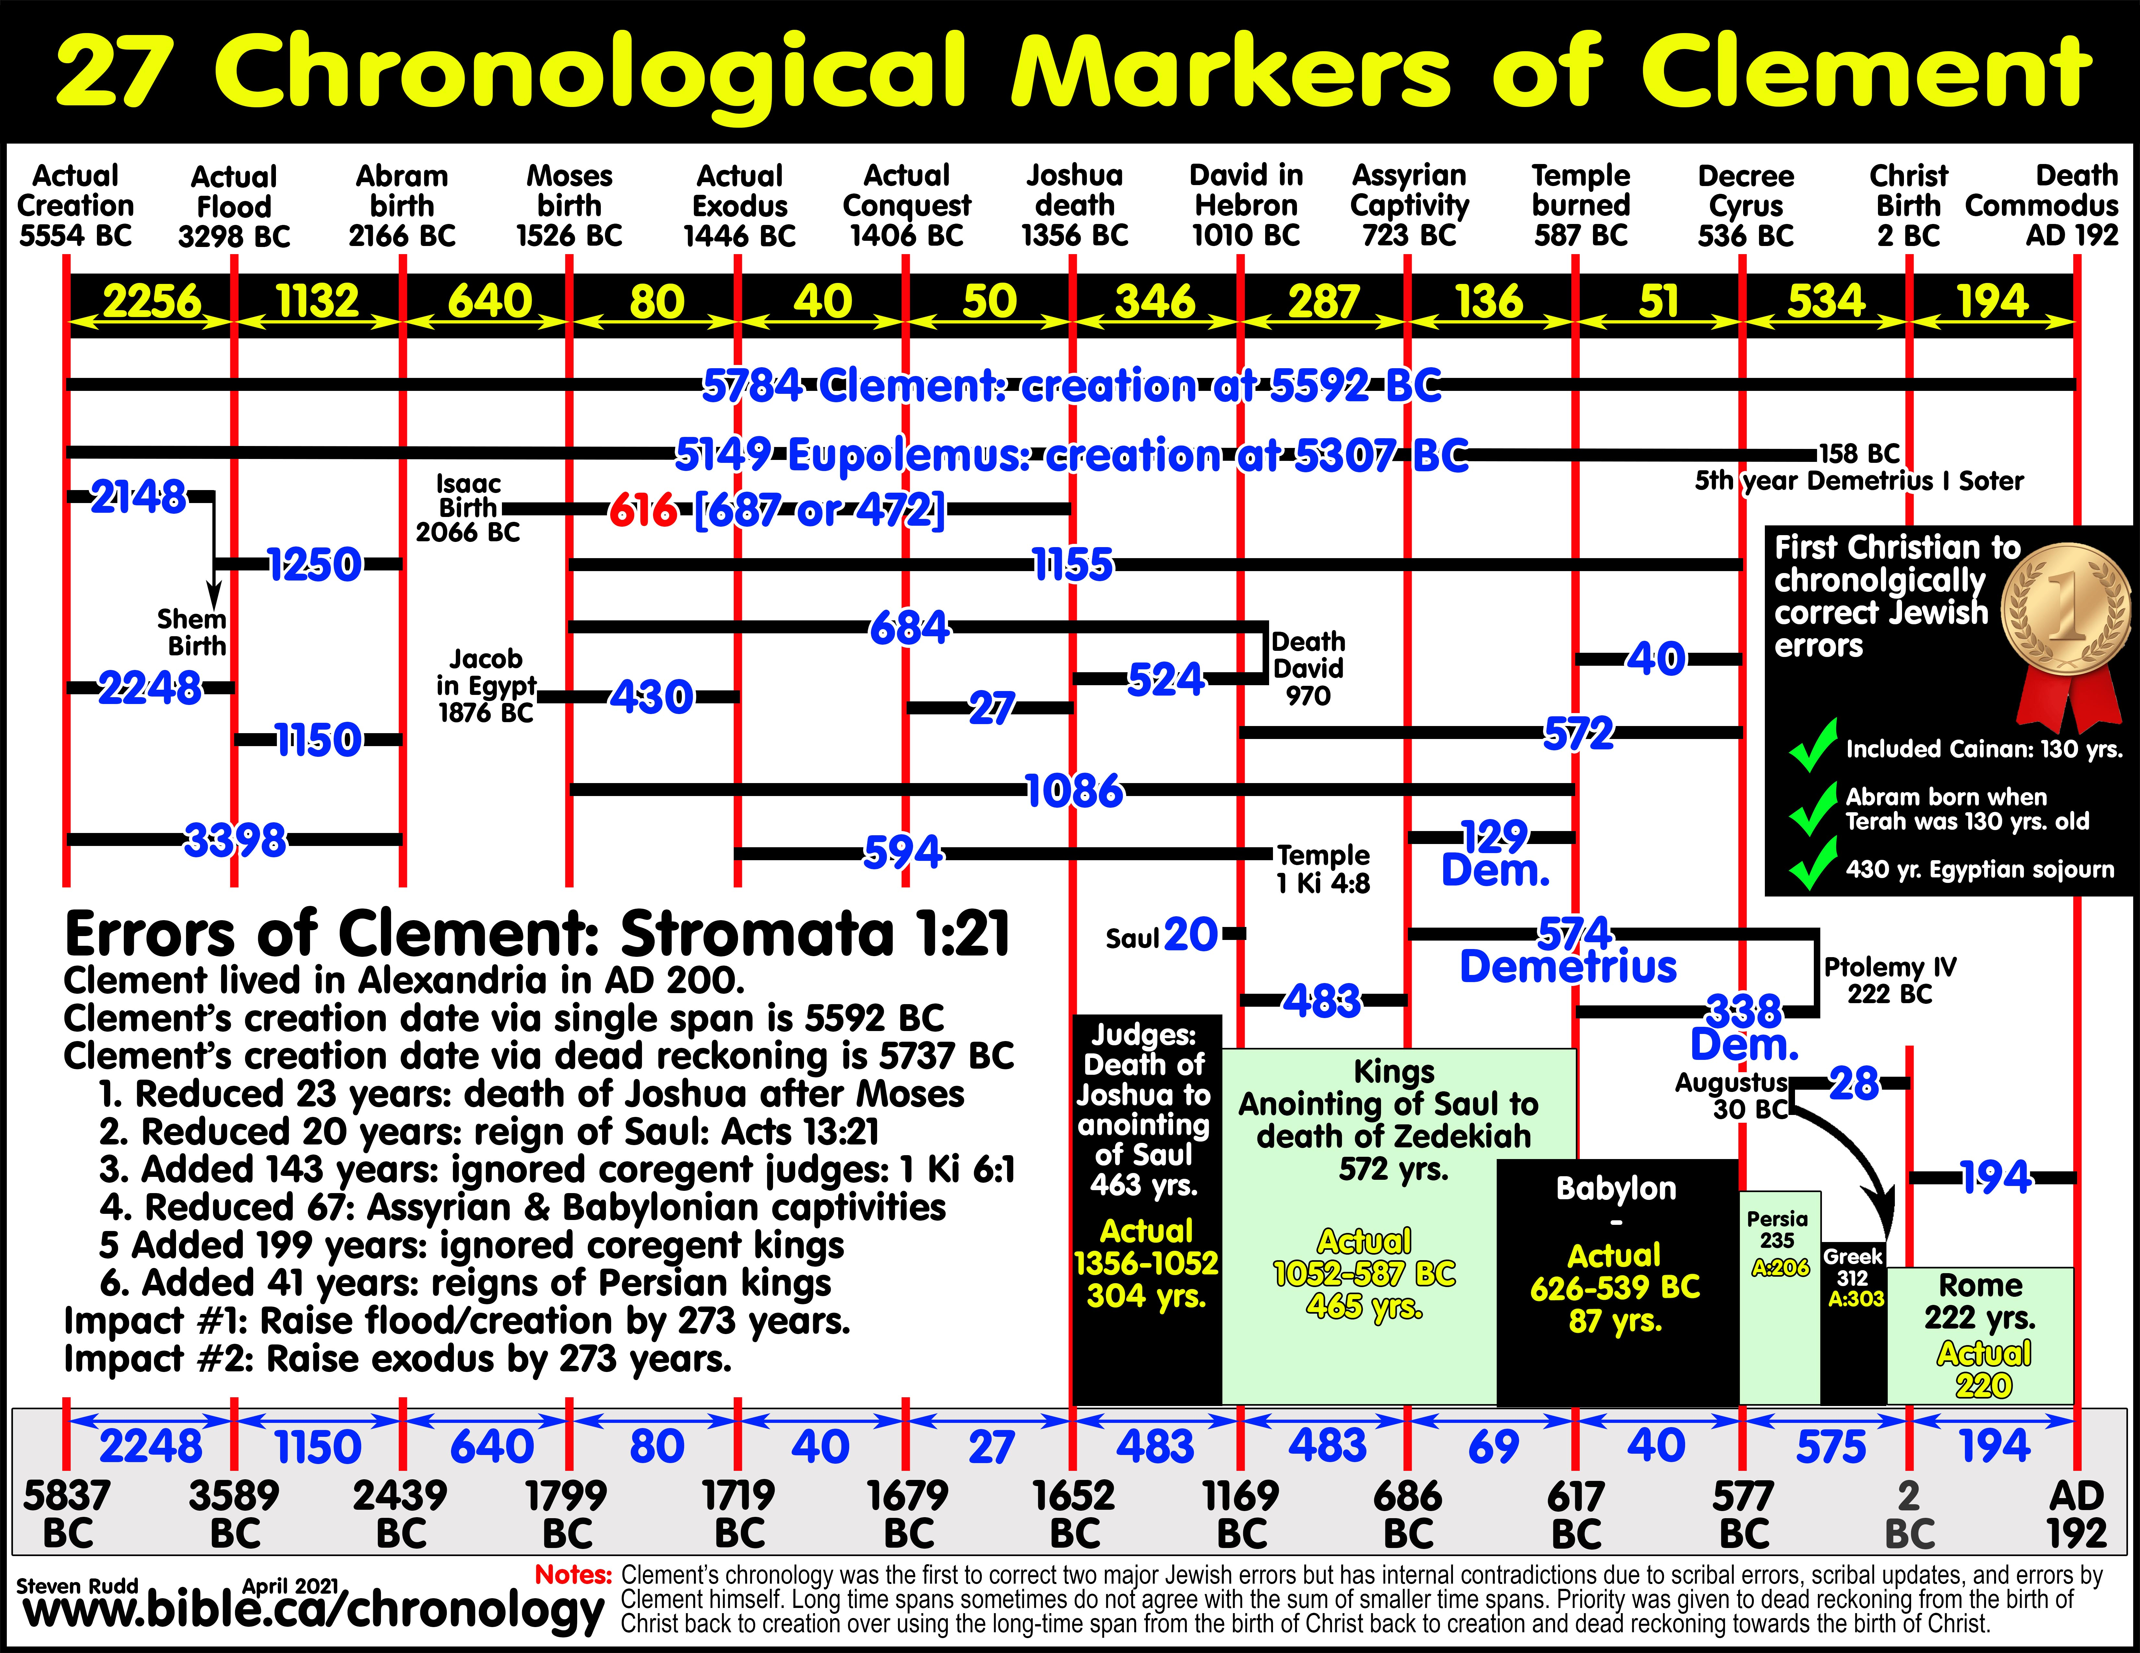](https://www.bible.ca/chronology/Chronology-Clement-of-Alexandria-Miscellaneous-1-21-Stromata-date-birth-Jesus-creation-flood-Noah-Egypt-sojourn-exodus-solomons-temple-detroyed-babylonian-captivity-200AD.jpg)

**[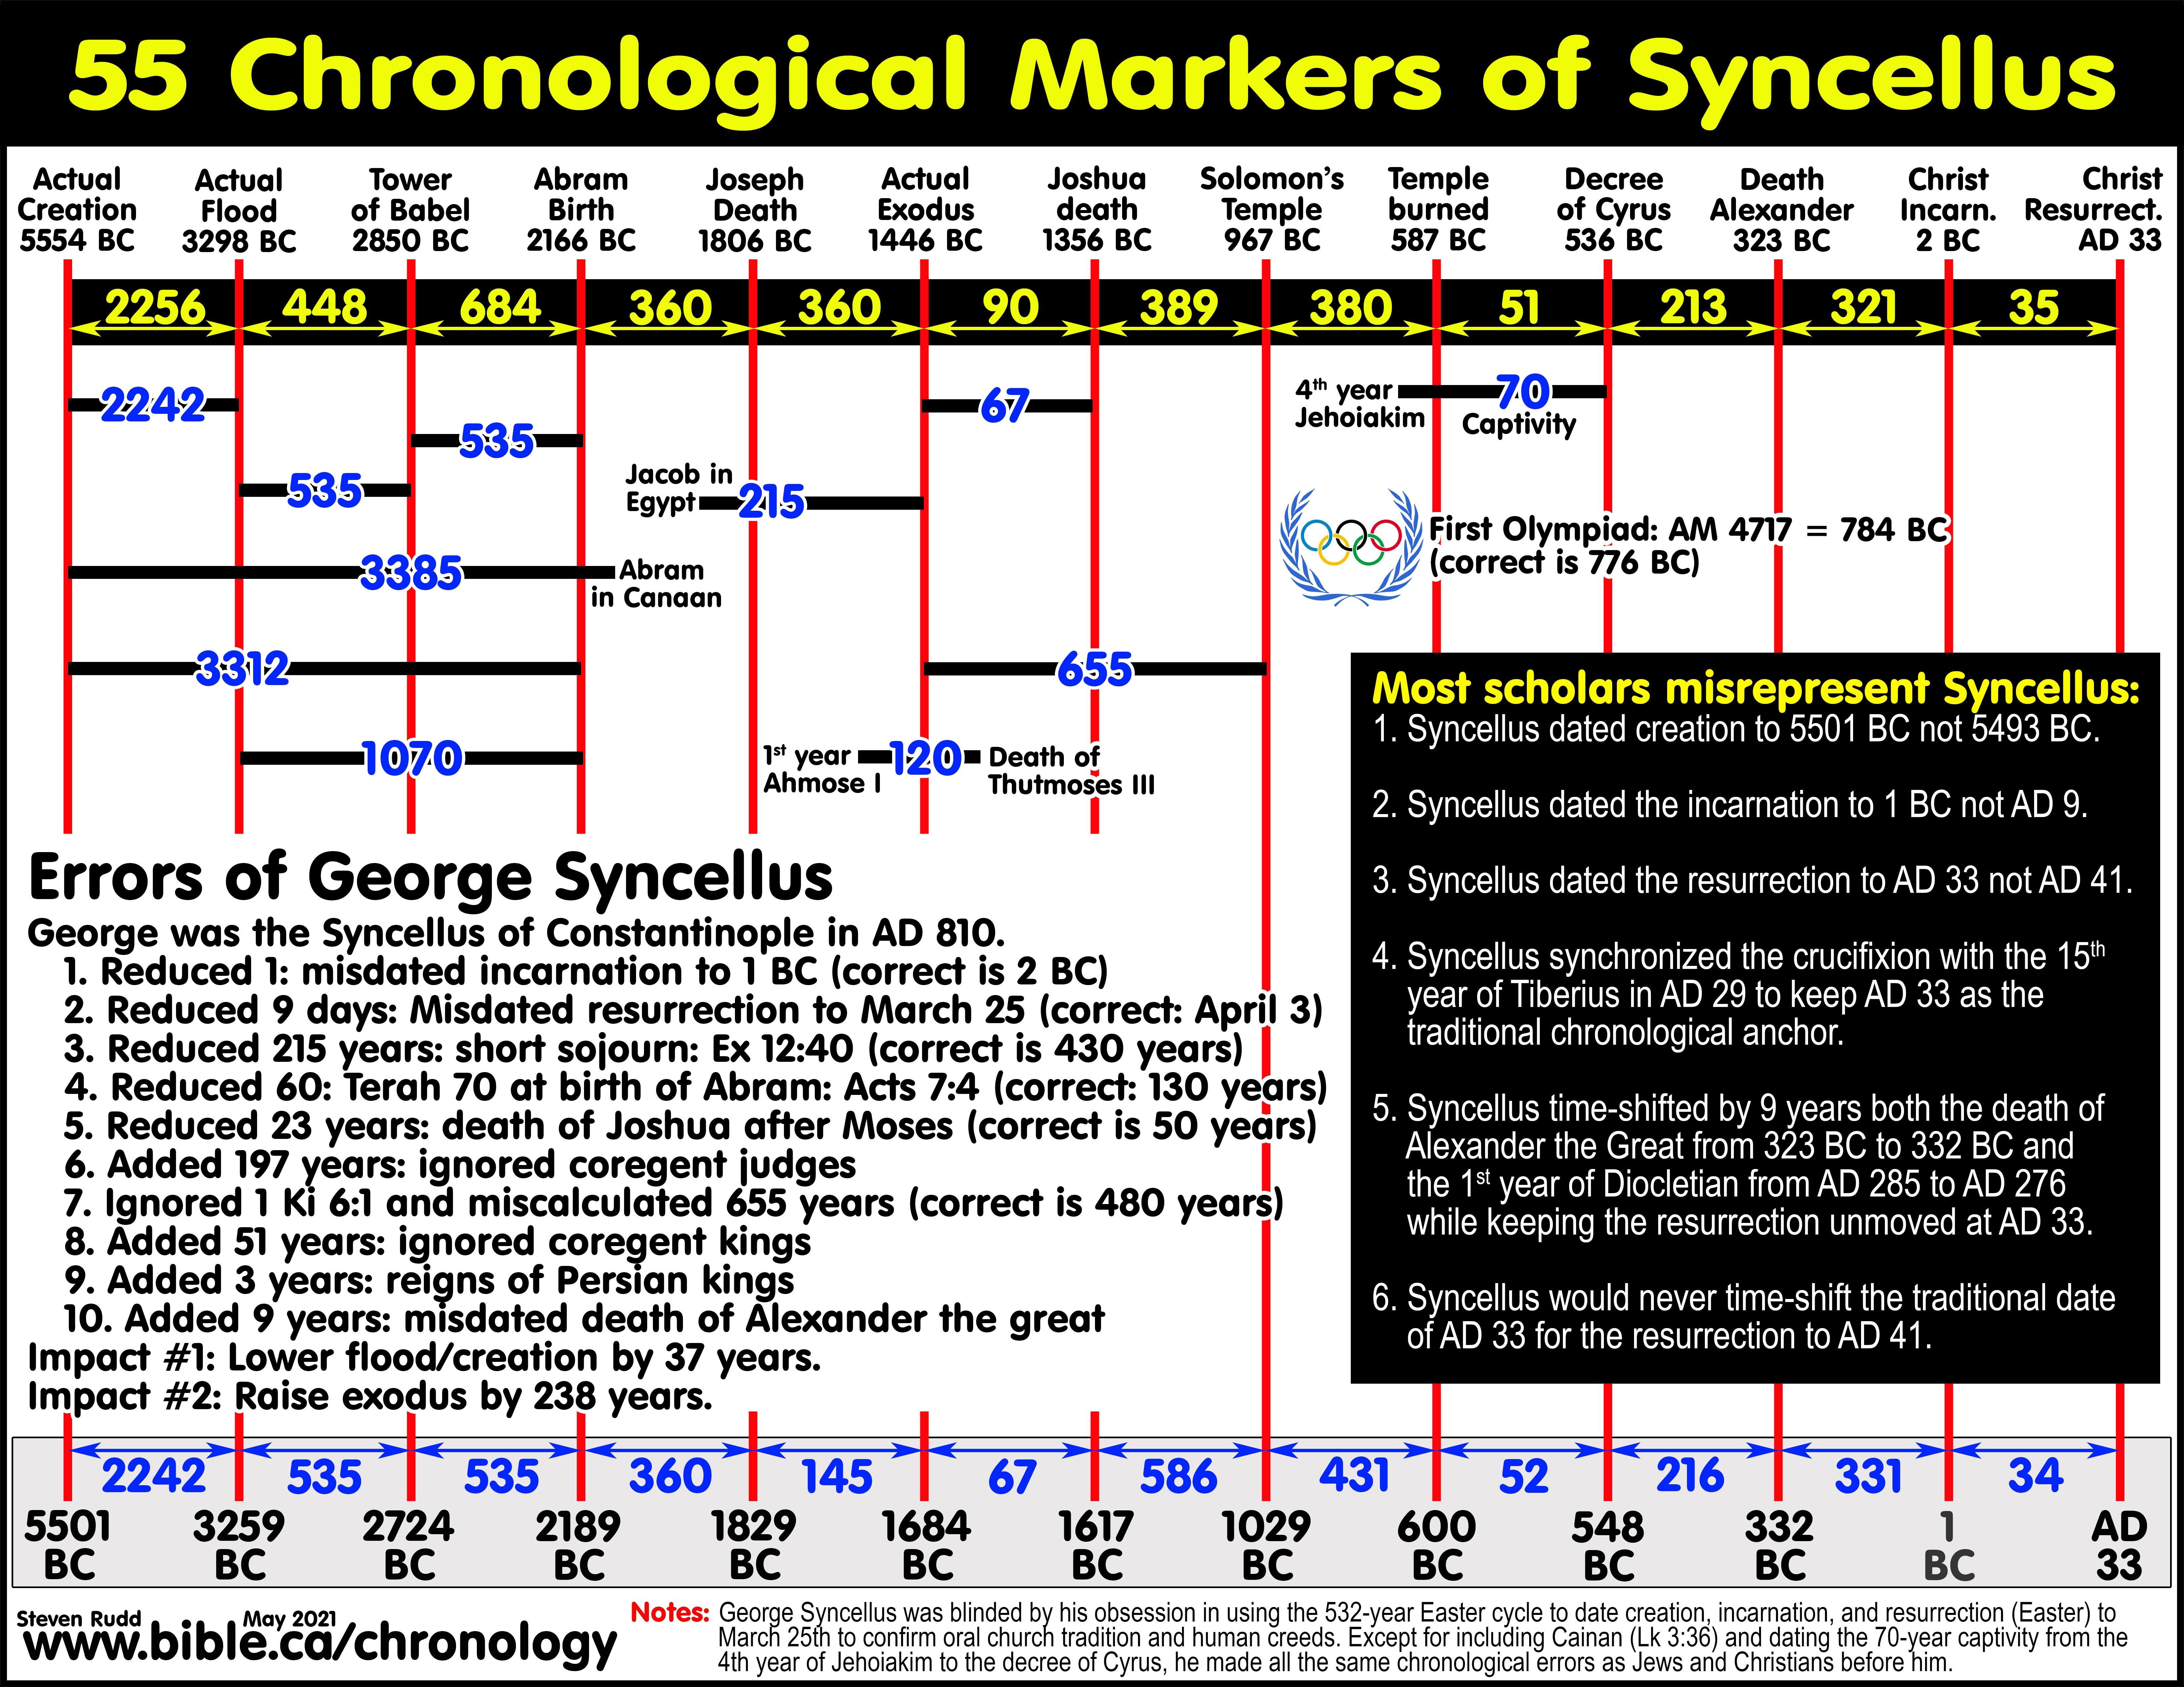](https://www.bible.ca/chronology/Chronology-George-Syncellus-Synkellos-Constantinople-Chronographia-date-birth-Jesus-creation-flood-Noah-Egypt-sojourn-exodus-Manetho-Africanus-Eusebius-810AD.jpg)**

Date and Pharaoh of the exodus from 23 ancient Jewish, Pagan, and Christian literary sources

Steven Rudd, Dallas 2021, ETS/NEAS

[Canada@bible.ca](mailto:Canada@bible.ca) [www.bible.ca/exodus](http://www.bible.ca/exodus)

1. **Pre-Christian Jewish Chronological errors corrected by the New Testament**:

|  |  |
| --- | --- |
| * 1. Many but not all pre-Christian Jews skipped the 130 years of Kainan. This was corrected in New Testament in Luke 3:36 and witnessed in the earliest extant  manuscript of Luke, Papyrus 4, AD 150.   2. Jews consistently misdated Terah as 70 years old when Abraham was born. They failed to notice that it was impossible for Terah’s three sons to be born the same year when he was 70 year old. This was corrected in New Testament to 130 years in Acts 7:4 by showing Abraham did not leave Haran until after his father died at age 130.   3. Jews consistently used the short sojourn of 215 years in Egypt. This was corrected in New Testament to 430 years in Exodus 12:40; Galatians 3:17.   4. Jews consistently misdated the reign of Saul to 20 years, likely because of textual variants in the book of Samuel. This was corrected in New Testament to 40 years in Acts 13:21.   5. Jews consistently miscalculated the number of years Joshua lived after crossing the Jordan to 23 years. This error was corrected in New Testament to 50 years. Joshua was the type of Sabbath rest in Hebrews 4:8 (weekly, 7 year sabbath and 49-year Jubilee). They missed that he was the “youth servant” of Moses” and about 20 years old at Mt. Sinai (Ex 33:11; Num 11:28). Joshua must have lived at least one year after the first 49-year Jubilee after crossing the Jordan in 1406 BC. The death of Joshua in 1356 BC, plus 6 years, began the period of the Judges. |  |

1. **All ancient Jews and Christians favored the early date of the exodus** (18th Dynasty) but all ancient pagans and Bible scoffers favored the late date of the exodus around the time of Ramses II in the 19th Dynasty. The same is true today.
   1. **1446 BC:** The “early date” of the 15th century BC exodus is historically vindicated as true. The “early exodus date” in the 18th Dynasty was the universal opinion of all Christians. While they misdated both the exodus and Egyptian chronology by hundreds of years, they targeted a Pharaoh named “Thutmose”. Their relative Egyptian chronology was correct and when you time-shift it into conformity with our knowledge today, they were remarkably close to 1446 BC. George Syncellus not only chose the right Pharaoh of the exodus (Thutmoses III), his exodus date, when you adjust his relative chronology, was within 10 years of 1446 BC.
   2. **1253 BC:** The “late date” of the 13th century BC exodus was historically rejected by Christians as lies and myths. The pagan Egyptians and Romans promoted lies that the exodus occurred at the time of Ramses II. Pseudo-Manetho’s “leper Pharaoh” of the exodus was Merneptah, the son of Ramses II. The pagan origin of the late exodus date should serve as a warning to Christians today who promote Ramses II as the Pharaoh of the exodus in 1253 BC. It also directly contradicted scripture in 1 Kings 6:1. Some Christians today have failed to recognize the pagan origin of December 25th as the birth of Christ. Likewise, some Christians today have failed to see the pagan origin of choosing Ramses II as the Pharaoh of the exodus in 1253 BC. This historic survey is a loud wake up call to any who embrace the late date.
2. **First century Jews and Christians down to AD 200 widely believed a king named “Thutmoses” was the Pharaoh of the exodus** synchronized with the first king of Manetho’s 18th Dynasty list, which we know today was Ahmoses I. It remains unsettled whether this association of the exodus Pharaoh with a Pharaoh named “Thutmoses” came from ancient Jewish oral and written tradition or from their analysis of Manetho’s Egyptian Chronology synchronized with their flawed Bible chronology.
   1. They may have first concluded from Jewish oral and written traditions that a man named “Thutmoses” was the Pharaoh of the exodus then went looking in Manetho’s Egyptian chronology for a Pharaoh that matched their exodus date. Knowing in advance that the Pharaoh of the exodus was named “Thutmoses”, early Christians scanned the Pharaonic names of the early 18th Dynasty in Manetho’s Egyptian chronology and chose the 1st Pharaoh in the list named “Thutmoses” whom we know today as Ahmose I. This was the wrong choice for the right reason. Thutmoses III might have been chosen by these early Christians had they recognized his throne name “Mephramuthosis” was an alternative for “Thutmoses”.
   2. They may have first, calculated the date of the exodus with their Bible chronology and then second, went looking for a Pharaoh in Manetho’s Egyptian chronology and chose Thutmoses.
   3. Today we know that Manetho’s Egyptian chronology was wrong in naming the 1st Pharaoh of the 18th Dynasty “Thutmoses”. Ahmoses I was mistakenly called “Thutmoses” by Manetho, Josephus and Theophilus. They wrongly assumed Thutmoses was an alternate throne name for the first king of the 18th Dynasty. This error persisted until it was corrected by Africanus and Eusebius when they swapped out “Thutmoses” for the correct “Ahmoses” in their versions of Manetho’s Egyptian chronology. Africanus followed Josephus and Theophilus in identifying the Pharaoh of the exodus with the 1st Pharaoh of the 18th Dynasty despite using two different names. Christians continued to associate the exodus with the 1st Pharaoh of the 18th Dynasty despite swapping out “Thutmose” for the correct “Ahmose”. Eusebius was the first and only Christian to wrongly choose Akhenaten as the Pharaoh of the exodus. In AD 810, George Syncellus compounded the error by wrongly concluding that “Thutmose” was an alternate and synonymous name for and “Ahmose I”. However, George Syncellus assessed all the chronological data before him and correctly concluded that Thutmoses III was the Pharaoh of the Exodus despite misdating the exodus by 238 years to 1684 BC.
   4. Looking back from the present it was truly a confusing comedy of errors, but they got two things right. The first thing they got right was that a king named “Thutmoses” was the Pharaoh of the exodus. And second, that the exodus dated to the early 18th Dynasty.
3. The only logical explanation why the earliest Jews and Christians identified the Pharaoh of the exodus as the first king of the 18th Egyptian Dynasty is an oral and written tradition that associated the exodus with a Pharaoh named “Thutmoses”.
   1. Most early Jews and Christians associated a triple chronological synchronism of Inachus with the 1st Pharaoh of the 18th Dynasty and the exodus.
   2. Biblical and Egyptian chronology were locked in a synchronism that erred by hundreds of years. The earliest Christians dated the start of the 18th Dynasty to between 1700-1800 BC. Keep in mind that today, we know Joseph died in 1806 BC!
   3. All early Christians made the error of allowing Egyptian chronology to trump Biblical chronology because it was widely understood that the Pharaoh of the exodus was named “Thutmoses”. They were caught in the dilemma of either abandoning Manetho’s Egyptian Chronology and ignoring Biblical chronology or vice versa. If they had used the Bible alone and ignored oral tradition (which ironically in this case was correctly identified Thutmoses) and also ignored Manetho’s chronology, they would have dated the exodus to 1446 BC but chosen the wrong Pharaoh of the exodus.
   4. If only the early Christians knew what we know today that Manetho’s Egyptian chronology was time-shifted 238 years higher, they could have correctly dated the exodus to 1446 BC and chosen Thutmoses III as the correct Pharaoh of the exodus.
   5. What is clear, is that early Christians were therefore driven to identify a Pharaoh named “Thutmoses” in the 18th Dynasty out of universal agreement of oral and written traditions and were unaware that both their Biblical and Egyptian chronologies erred by 238 years.
4. **Birth and resurrection of Christ:** Most early Christians dated the birth of Christ to 2 BC with a resurrection in AD 33.
   1. Tertullian dated the birth of Christ to 2 BC: “In the 41st year of the empire of Augustus, when he has been reigning for 28 years after the death of Cleopatra, the Christ is born (2 BC).” (Tertullian, Answering Jews 8, 200 AD)
   2. Africanus and Dionysius erred in dating the resurrection to AD 30 because they allowed for only a one year ministry of Christ. This should serve as a wakeup call for those to continue to say Christ died in AD 30.
5. **Dating the Tower of Babel:** George Syncellus is the only ancient chronologer who ventured to date the Tower of Babel. His date for the division of languages of 2724 BC was only 125 years short of the correct 2850 BC. Syncellus erred in dating the Tower of Babel to the time of Peleg instead of the time of his father Heber.
   1. Heber was a “Babel Vet” who eye witnessed the Tower of Babel division and had his native universal language changed into the new language of Hebrew. Peleg was born after the division of language as a “Babel Baby Boomer” and was the first descendant in the Shem genealogy to learn Hebrew as his native tongue from infancy. We can prove this because his name “Peleg” means “division” and he never would have been given this birth name if he had been born before the division event, only afterwards. Had Syncellus understood this, he would have correctly dated the Tower of Babel to 2850 BC.
   2. “Heber named his son “Divided” because the division took place before Peleg was born. Peleg was born into a world ALREADY DIVIDED into languages and lands which is the reason Heber named him “Division”. Heber named his son Peleg as a memorial of the Division that occurred at the Tower of Babel. Peleg is a memorial name of a major historic event that preceded his birth: the division of languages and land resulting from the failed attempt to build the Tower of Babel.” (Nimrod and the Archaeology of the Tower of Babel, Steven Rudd, p27, 2019 AD)
6. **70 weeks of Daniel 9:** The 490 years started in 458 BC, which we know today, is the 7th year of Artaxerxes as per Ezra 7, and ended exactly 490 solar years *to the day* on 5th April AD 33. Jesus was baptized in AD 29, had a 3.5 year ministry and was crucified on 3 April AD 33. Most early Christians understood the 490 years of Daniel 9 as a continuous sequence of years without any time gaps. The 70 weeks of Daniel was difficult for the early Christians to pinpoint because their Persian chronology erred by between 15 and 50 years which meant that the prophecy would end between AD 30-70. The beginning point of the 70 weeks was also difficult to for them to assign.
   1. Africanus, Syncellus and Origin correctly marked the end point of the 70 weeks of Daniel at the resurrection of Christ. “The weeks of years, also, which the prophet Daniel had predicted, extending to the leadership of Christ, have been fulfilled. (Origen, De princ. 4.1.5).
      1. Africanus counted the 70 weeks as 475 years from 445 BC to AD 30 using lunar years. Africanus started the 490 “solar” years in the 20th year of Artaxerxes, which in his chronology, was 445 BC and ended in AD 45. This was obviously wrong, so he fabricated the idea, suggested by local Jews, that the Hebrews used lunar years, not solar. The 490 solar years translated into 475 lunar years which was a perfect match for his AD 30 crucifixion. He dated the baptism of Jesus to AD 29, with a 1 year ministry and crucifixion in AD 30.
   2. Eusebius began the 70 weeks with the construction of the temple in the 6th year of Darius I (515 BC) and ended the 69th week in 30 BC with the death of Hyrcanus. He inserted a 28 year gap between the 69th and 70th weeks. The 70th week began with the baptism of Jesus in AD 29 where the end of the first 3 ½ years coincided with the crucifixion and the end of the second 3 ½ years coincided with AD 37. Eusebius’ 70 weeks was a total of 552 years: 515 BC – AD 37.
   3. Hippolytus inserted a 500 year gap beginning with the incarnation of Christ 5500 years after creation and ending in the second coming in AD 500 at the conclusion of the last day of the final 3 ½ years. Hippolytus predicted the second coming when the earth was exactly 6000 years old. Christ was born AC 5500 + 500 years = AC 6000 = AD 500.
   4. Josephus deliberately redefined the end point of Daniel 9 to AD 70 to break the widely understood synchronism with coming of Jesus of Nazareth. Aphrahat, Tertullian and Sulpicius Severus also marked the end in AD 70 because their Persian chronologies were all wrong and they likely trusted that Jewish Josephus might be right.
      1. “Vespasian, in the first year of his empire, subdues the Jews in war; and there are made 70 years, 6 months. For he reigned 11 years. And thus, in the day of their storming, the Jews fulfilled the 70 hebdomads (periods of 7 years) predicted in Daniel.” (Tertullian, Answering Jews 8, 200 AD)
      2. “But the completion of the restored city is related to have been effected in the thirty-second year of the reign of Artaxerxes. From that time to the crucifixion of Christ; that is, to the time when Fufius Geminus and Rubellius were consuls (AD 29), there elapsed 398 years. But from the restoration of the temple to its destruction, which was completed by Titus under Vespasian, when Augustus was consul, there was a period of 483 years. That was formerly predicted by Daniel, who announced that from the restoration of the temple to its overthrow there would elapse 69 weeks.” (Sulpicius Severus, Sacred History 2.11, AD 420)
7. **Manetho’s leper exodus Pharaoh whom he called “Amenophis” was identified with Merneptah, the son of Ramses II**.
   1. Manetho’s original Egyptian chronology in 282 BC was lost. This original of Manetho was corrupted around 167 BC into “Pseudo-Manetho” that included the leper exodus narrative for the first time. Today, three different extant manuscript families of Manetho are identified.
   2. The chronological calculations of Josephus identified Merneptah, the son of Ramses II with certainty.
   3. It is impossible for Amenhotep II or Amenhotep III to be the leper Pharaoh “Amenophis” because chronologically Amenhotep III [Orus] preceded Amenophis. (Ag. Ap. 1.96 + 232).
   4. Amenhotep IV (Akhenaten) cannot be the leper Pharaoh Amenophis because of the chronological calculation of Josephus. While Akhenaten is the only possible contemporary match with the real historical scribe Amenophis, son of Papis, the weight of evidence is that the “son of Papis” was time shifted 150 later from the time of Akhenaten to the time of Ramses II, then mythically grafted into the leper narrative. The fact that an alternate version of the leper narrative substituted the “Oracle of Ammon” for the “Prophet Amenophis” is good evidence that any historical connection to Akhenaten’s scribe must be rejected. Finally, Akhenaten is the Pharaoh of the Amarna Letters which documented the conquest of Joshua in hundreds of clay cuneiform tablets and lived 90 years after the actual exodus. Akhenaten began to reign about the same time that Joshua died. Akhenaten took all the royal correspondence between the city kings of Canaan and his father and grandfather and moved them to Amarna where he housed them in a library.
   5. An alternate version of the leper exodus narrative substituted Bocchoris (728–723 BC) for Amenophis as the leper Pharaoh. The two versions coexisted at the time of Josephus. This supported the conclusion that the entire leper narrative was a fabrication during the time of Antiochus IV when hostilities towards the Jews peaked. Dating the exodus to the time of the Assyrian captivity in 723 BC with Bocchoris (728–723 BC) as the Pharaoh of the exodus, directly contradicted the Bible and must be rejected.
8. **Creation and the age of the earth:** Despite 10 common chronological errors, ancient Jews and Christians were remarkably close to correct for the age of the earth at 5554 BC. The hundreds of extra error years after the exodus almost perfectly canceled out the hundreds of deficit error years before the exodus. Whether lucky fluke or divine providence, the result was the first century understanding by Josephus that the earth was about 5431 years old when Christ was born erred by only 123 years.
9. **Greek Septuagint (LXX) not the Hebrew Masoretic Text (MT):** Jewish Demetrius and every Christian chronologer used the longer numbers in Genesis 5 and 11 from the Septuagint not the corrupt numbers from the Masoretic text we use in our Bibles today. This is evidenced in the fact that they date the age of the earth older than 5000 BC. If they had used the MT of today, the age of the earth would be younger than 4174 BC. Josephus dated the age of the earth to 5431 BC using the extant Hebrew text in AD 70 (Josephus, Antiquities 10:218; Against Apion 1.1). The proto-Masoretic Hebrew text Josephus used in AD 70 in Gen 5 and 11, agreed with the LXX. This proves the corruption took place after Josephus in AD 160 in Zippori.

|  |  |  |  |  |  |  |  |  |  |  |  |  |
| --- | --- | --- | --- | --- | --- | --- | --- | --- | --- | --- | --- | --- |
| **Master Summary of 23 Ancient Literary Sources for the Pharaoh and Date of the Exodus** | | | | | | | | | | | | |
|  | **Creation** | **Flood** | **Exodus** | **Exodus Pharaoh** | **Pharoah Died** | **Cainan Lk 3:36** | **Birth Abram** | **Sojourn Ex 12:40** | **480 yrs. 1 Ki 6** | **Birth Christ** | **Death Christ** | **End of Dan 9:24-27** |
| 1. **167 BC Manetho** | — | — | 1210 BC | Amenophis/ Merneptah | — | — | — | — | — | — | — | — |
| 1. **220 BC Demetrius** | 5515 BC | 3251 BC | 1676 BC1 | — | — | Yes | — | 215 | No | — | — | — |
| 1. **Jubilees 170 BC** | 4086 BC | 2778 BC | 1676 BC1 | — | — | Omit | 70 | 238 | No | — | — | — |
| 1. **Josephus AD 70** | 5431 BC | 3173 BC | 1676 BC | Thutmoses/ Ahmoses I | No |  | 70 | 215 | 592 | — | — | AD 70 |
| 1. **AD 70 Apion** | — | — | 1210 BC | Amenophis/ Merneptah | — | — | — | — | — | — | — | — |
| 1. **AD 70 Cheremon** | — | — | 1210 BC | Amenophis/ Merneptah | — | — | — | — | — | — | — | — |
| 1. **AD 70 Lysimachus** | — | — | 723 BC | Bocchoris | — | — | — | — | — | — | — | — |
| 1. **AD 100 Tacitus** | — | — | 723 BC | Bocchoris | — | — | — | — | — | — | — | — |
| 1. **AD 160 Seder Olam** | 3761 BC | 2103 BC | 1311 BC | — | — | Omit | 70 | 209 | 4802 | — | — | — |
| 1. **AD 172 Tatian** | — | — | Inachus3 | Ahmose I | — | — | — | — | — | — | — | — |
| 1. **AD 185 Theophilus** | 5529 BC | 3287 BC | 1532 BC | Thutmoses/ Ahmoses I | Yes | Omit | 70 | 430 | 541 | 2 BC | AD 33 | — |
| 1. **AD 200 Clement** | 5837 BC | 3589 BC | 1719 BC3 | Ahmoses I | No | Yes | 130 | 430 | 594 | April 2 BC | AD 33 | AD 70 |
| 1. **AD 221 Africanus** | 5500 BC | 3238 BC | 1793 BC | Ahmoses I | No | Omit | 70 | 215 | 750 | 2 BC | AD 304 | AD 33 |
| 1. **AD 225 Hippolytus** | 5500 BC | — | — | — | No | — | — | — | — | — | — | AD 5005 |
| 1. **AD 235 Chronology** | 5446 BC | 3303 BC | 1570 BC | — | — | Yes | — | 430 | 640 | — | — | — |
| 1. **AD 325 Eusebius** | 5199 BC | 2958 BC | 1511 BC | Akhenaten | No | Omit | 70 | 215 | 4802 | 2 BC | AD 33 | AD 376 |
| 1. **344 AD Aphrahat** | — | — | 1516 BC | — | — | — | — | 225 | 480 | — | — | AD 70 |
| 1. **AD 380 Jerome** | 5201 BC | 2959 BC | 1512 BC | — | — | Omit | 70 | 215 | 480 | 2 BC | AD 33 | — |
| 1. **AD 400 Augustine** | — | — | 1512 BC | — | — | — | — | — | — | — | — | — |
| 1. **AD 412 Panodorus** | 29th Aug. 5493 BC | — | — | — | — | — | — | — | — | 1 BC | AD 33 | — |
| 1. **AD 412 Annianus** | 25th March 5501 BC7 | — | — | — | — | — | — | — | — | 25th March 1 BC7 | 25th March AD 337 | — |
| 1. **AD 525 Dionysius** | 25th March 5501 BC7 | — | — | — | — | — | — | — | — | 25th March 1 BC7 | 25th March AD 307 | — |
| 1. **AD 810 Syncellus** | 25th March 5501 BC7 | 3259 BC | 1684 BC | Thutmoses III | No | Yes | 60 | 215 | 655 | 25th March 1 BC7 | 25th March AD 337 | 25th March AD 33 |
| **CORRECT** | **5554 BC** | **3298 BC** | **1446 BC** | **Thutmoses III** | **No** | **Yes** | **130** | **430** | **480** | **2 BC** | **AD 33** | **AD 33** |
| 1: Assumed to be same as Josephus  2: Seder Olam counted 450 years for the period of the judges but calculated 480 years by counting only the Hebrew Judges reigns (338 years) and ignoring the oppressor reigns (111 years). Eusebius calculated 480 years by borrowing this delusional chronological solution from the Jews in Seder Olam.  3: Titian gave no date, but like others (Clement), synchronized with Inachus around 1700 BC in their flawed chronologies.  4: Africanus dated the baptism of Jesus to AD 29 and calculated only a 1 year ministry of Christ for a crucifixion in AD 30.  5: Hippolytus used a highly symbolic Midrashic hermeneutic in everything. He put a 500 year gap in the 70 weeks of Daniel 9 beginning with the incarnation of Christ and ending in the second coming in AD 500 at the conclusion of the last day of the final 3 ½ years. He believed the end came when the earth was 6000 year old.  6: Eusebius began the 70 weeks with the completion of the temple in the 6th year of Darius (515 BC) and ended the 69th week in 30 BC with the death of Hyrcanus. He inserted a 28 year gap between the 69th and 70th weeks. The 70th week began with the baptism of Jesus in AD 29 where the end of the first 3 ½ years coincided with the crucifixion and the end of the second 3 ½ years coincided with AD 37. Eusebius’ 70 weeks was a total of 552 years: 515 BC – AD 37.  7: Annianus, Dionysius, and Syncellus dated creation, incarnation, and resurrection to March 25th. Dionysius used a 1 year ministry of Christ with death in AD 30. | | | | | | | | | | | | |