**Noah as a gateway between two very different worlds**

**The name of Noah and the garden curse**

**Noah means “rest” in Hebrew. Rest from the garden curse:**

"Lamech lived one hundred and eighty-two years, and became the father of a son. Now he called his name Noah, saying, “This one will give us rest from our work and from the toil of our hands arising from the ground which the Lord has cursed.”" (Genesis 5:28–29)

**Noah released man from the curse after the flood:**

"Then Noah built an altar to the Lord, The Lord smelled the soothing aroma; and the Lord said to Himself, “I will never again curse the ground on account of man, for the intent of man’s heart is evil from his youth; and I will never again destroy every living thing, as I have done." (Genesis 8:20–21)

**Pre-food world of Adam to Noah:**

1. Waters above and waters below: Genesis 1:7
   1. Twice atmospheric pressure
   2. Gigantism in the fossil record
   3. Men lived to be 1000 years old
2. Global greenhouse:
   1. Global warming of 5 to 10 degrees.
   2. No ice on the polar caps
   3. Fossil palm trees found on poles.
3. Never rained, only a mist: Genesis 2:6
4. Garden curse was rapid growth:
   1. Combined with giantism, 500 foot canopy of trees. (Today tropical forest canopies are 200 feet)
   2. Adam would clear land and the weeds would grow so fast, they would choke out crops.
   3. All fossil fuels (oil, coal, gas) are a flood deposit. (500 feet of vegetation covering the globe was deposited under a flood deposit of 1.5 miles.

**Noah’s name in Chinese pictographs means “the second promise/approved”:**

1. Although spelled/pictorialized differently, Noah’s name sounds the same in both Hebrew, English and Chinese.
2. As we look at the etymology of Noah's name, we find that he is the SECOND APPROVED. There are only two men of whom it is had been said in Scripture, he "walked with God."

[[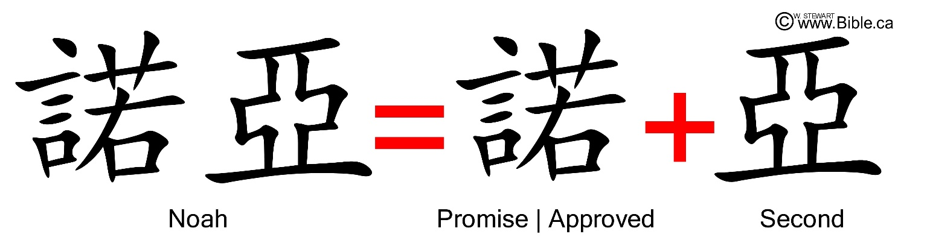](https://www.bible.ca/ark/chinese/bible-evidences-chinese-language-characters-words-noah-flood-genesis-5-29-nuoya-noah-second-promise-approved-words-man-weeds-life-earth.jpg)](https://www.bible.ca/ark/chinese/bible-evidences-chinese-language-characters-words-noah-flood-genesis-5-29-nuoya-noah-second-promise-approved-words-man-weeds-life-earth.jpg)

The first to receive such approval from the Lord was Noah's great-grandfather Enoch, of whom it is said,

* *Enoch walked with God; and he was not, for God took him.* (Genesis 5:24)

One chapter later, we find that

* *Noah found grace in the eyes of the Lord. This is the genealogy of Noah. Noah was a just man, perfect in his generations. Noah walked with God.* (Genesis 6:8-9)

**The Chinese pictograph in Noah’s name for approved/promise:**

[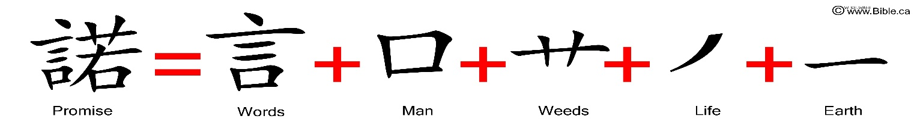](https://www.bible.ca/ark/chinese/bible-evidences-chinese-language-characters-words-noah-flood-genesis-5-28-29-nuo-promise-words-man-weeds-life-earth.jpg)

**Two promises God made because of Noah:**

1. remove garden curse
2. never destroy with water

“I will never again curse the ground on account of man, for the intent of man’s heart is evil from his youth; and I will never again destroy every living thing, as I have done." (Genesis 8:20–21)

Steven Rudd Nov 3, 2021

