**Resurrection in the Old Testament: Elijah/Elisha as types of John/Christ**

1. 10 miracles of resurrection from the dead in the Bible: 3 Old Testament, 7 New Testament
   1. Elijah: Widow of Zarephath's Son: 1 King 17:17-24
   2. Elisha: Shunammite Woman's Son: 2 Kings 4:18-37
   3. Elisha: Israelite Man who touched the bones of Elisha: 2 Kings 13:20-21
   4. Widow of Nain's only Son: Luke 7:11-17
   5. Jairus' only Daughter: Mark 5:38-43; Luke 8:40-56
   6. Lazarus: John 11:1-44
   7. Jesus Christ: Matthew 28:1
   8. Jerusalem saints when Christ died: Matthew 27:50-54
   9. Tabitha or Dorcas: Acts 9:36-42
   10. Eutychus: Acts 20:7-12
2. Elisha’s “double measure” or double portion of Elijah’s ministry is seen in:
   1. Elijah had a 35-year ministry and Elisha 70 year ministry.
   2. Elijah predicted a 3.5-year drought and Elisha predicted a 7-year drought: 2 Kings 8:1
   3. Elijah raised one person from the dead and Elisha two: 1 Ki 17:17; 2 Ki 4:32; 13:20. One man was raised by the dead body of Elisha (who had the double portion) but many were raised by the dead body of Jesus who had the messianic double portion: Mt 27:52. Then at the last day every man on earth will be raised from the dead.
   4. The Messiah (like Elisha) was prophesied to get double portion: Isa 61:1-7. In Luke 4:18-28, Jesus quoted Isa 61 in his hometown synagogue in Nazareth and said He had fulfilled it. The Jews would know the text well and recognize that Jesus was claiming the “double portion” of Elisha upon himself in performing miracles. They requested miracles to prove his claim. Jesus’ answer by directly named Elijah and Elisha in Lk 4:25-27. There is a direct tie between the double portion of Elisha and Jesus.

**Use of the number 3 ½, 3 and 7 by Elijah and Elisha as source for Daniel and Revelation**

1. It is no coincidence that the church began exactly “7” weeks after Christ was crucified: Passover to Pentecost was 49 days or 7 x 7 weeks.
2. The number 3.5: Elijah, Daniel, Revelation:
   1. Elijah had a 35 year ministry from 877 – 842 BC. (Elisha had a 70 year ministry because of his double measure)
   2. The famous drought of Elijah was 3 ½ years: Jas 5:17
   3. The number 3.5: and Daniel/Nero/Revelation: [Daniel 7](https://www.bible.ca/revelation/Bible-Only-Revelation-commentary-Steven-Rudd-Daniel-5-kingdoms-1260-days-42-months-70-weeks-490-years-2300-1290-days-43-months.htm#dan7): 3.5 years: The 1260 Days, 42 months: Nero persecution: 64-68 AD
   4. The number 3.5: and Daniel/Christ’s Resurrection: [Daniel 9](https://www.bible.ca/revelation/Bible-Only-Revelation-commentary-Steven-Rudd-Daniel-5-kingdoms-1260-days-42-months-70-weeks-490-years-2300-1290-days-43-months.htm#dan9): 70x7: The 70 weeks, 490 years ending at Resurrection of Christ
   5. The number 3.5: and Daniel/Christ’s Ministry: [Daniel 12](https://www.bible.ca/revelation/Bible-Only-Revelation-commentary-Steven-Rudd-Daniel-5-kingdoms-1260-days-42-months-70-weeks-490-years-2300-1290-days-43-months.htm#dan12): 3.5 years + 1 month: The 1290 Days, 43 months: Ministry of Christ up to between the Ascension and Pentecost.
3. The number 3:
   1. Elijah “stretched himself upon the child three times” when he raised the widow of Sidon’s son from the dead: 1 Kings 17:21
   2. Elijah poured four buckets of water over the alter, three times, for a total of 12 buckets of water: 1 Kings 18:34
   3. The three prophet’s schools of Elijah: Gilgal, Bethel and Jericho. Three times Elijah told Elisha to remain in at each prophet’s school: 2 Kings 2:1ff and 2 Kings 4:38
   4. Men searched in vain for three days for Elijah after he was taken to heaven: 2 Kings 2:17
   5. Ahaziah sent three sets of 50 solders to arrest Elijah, who killed the first two sets of 50: 2 Ki 1:9-13
4. The number 7 in the Elijah and Elisha stories:
   1. Elijah prayed 7 times for it to rain again after the 3.5-year drought: 1 Kings 18:43
   2. Elisha performed the miracle of water on the 7th day of the Battle of Moab in 849 BC: 2 Kings 3:9-20
   3. Elijah was told by God that there were 7000 righteous men in addition to himself: 1 Kings 19:18 (Ahab defeated Ben-Hadad II with an army of 7000 men: 1 Kings 20:15)
   4. Elisha raised the Shunammite’s son from the dead by laying on him 7 times and the boy sneezed 7 times before he woke up. Note. There is a variant between the MT and the LXX. The LXX is probably correct:
      1. **LXX:** "He turned and went in the house up and down. He ascended and bent down over the boy for seven times, and the boy opened his eyes." (4 Kingdoms 4:35, Greek Septuagint, LXX)
      2. **MT:** “Then he returned and walked in the house once back and forth, and went up and stretched himself on him; and the lad sneezed seven times and the lad opened his eyes." (2 Kings 4:35, Hebrew Masoretic Text, MT)
   5. Elisha told Naaman to dip in the Jordan 7 times: 2 Kings 5:10
   6. Elisha caused a 7-year drought (double portion of Elijah’s power: 3.5 year drought of Elijah = 7 year drought of Elisha): 2 Kings 8:1
   7. Elisha’s ministry lasted exactly 70 years from 865-795 BC

Steven Rudd 3 November 2021

[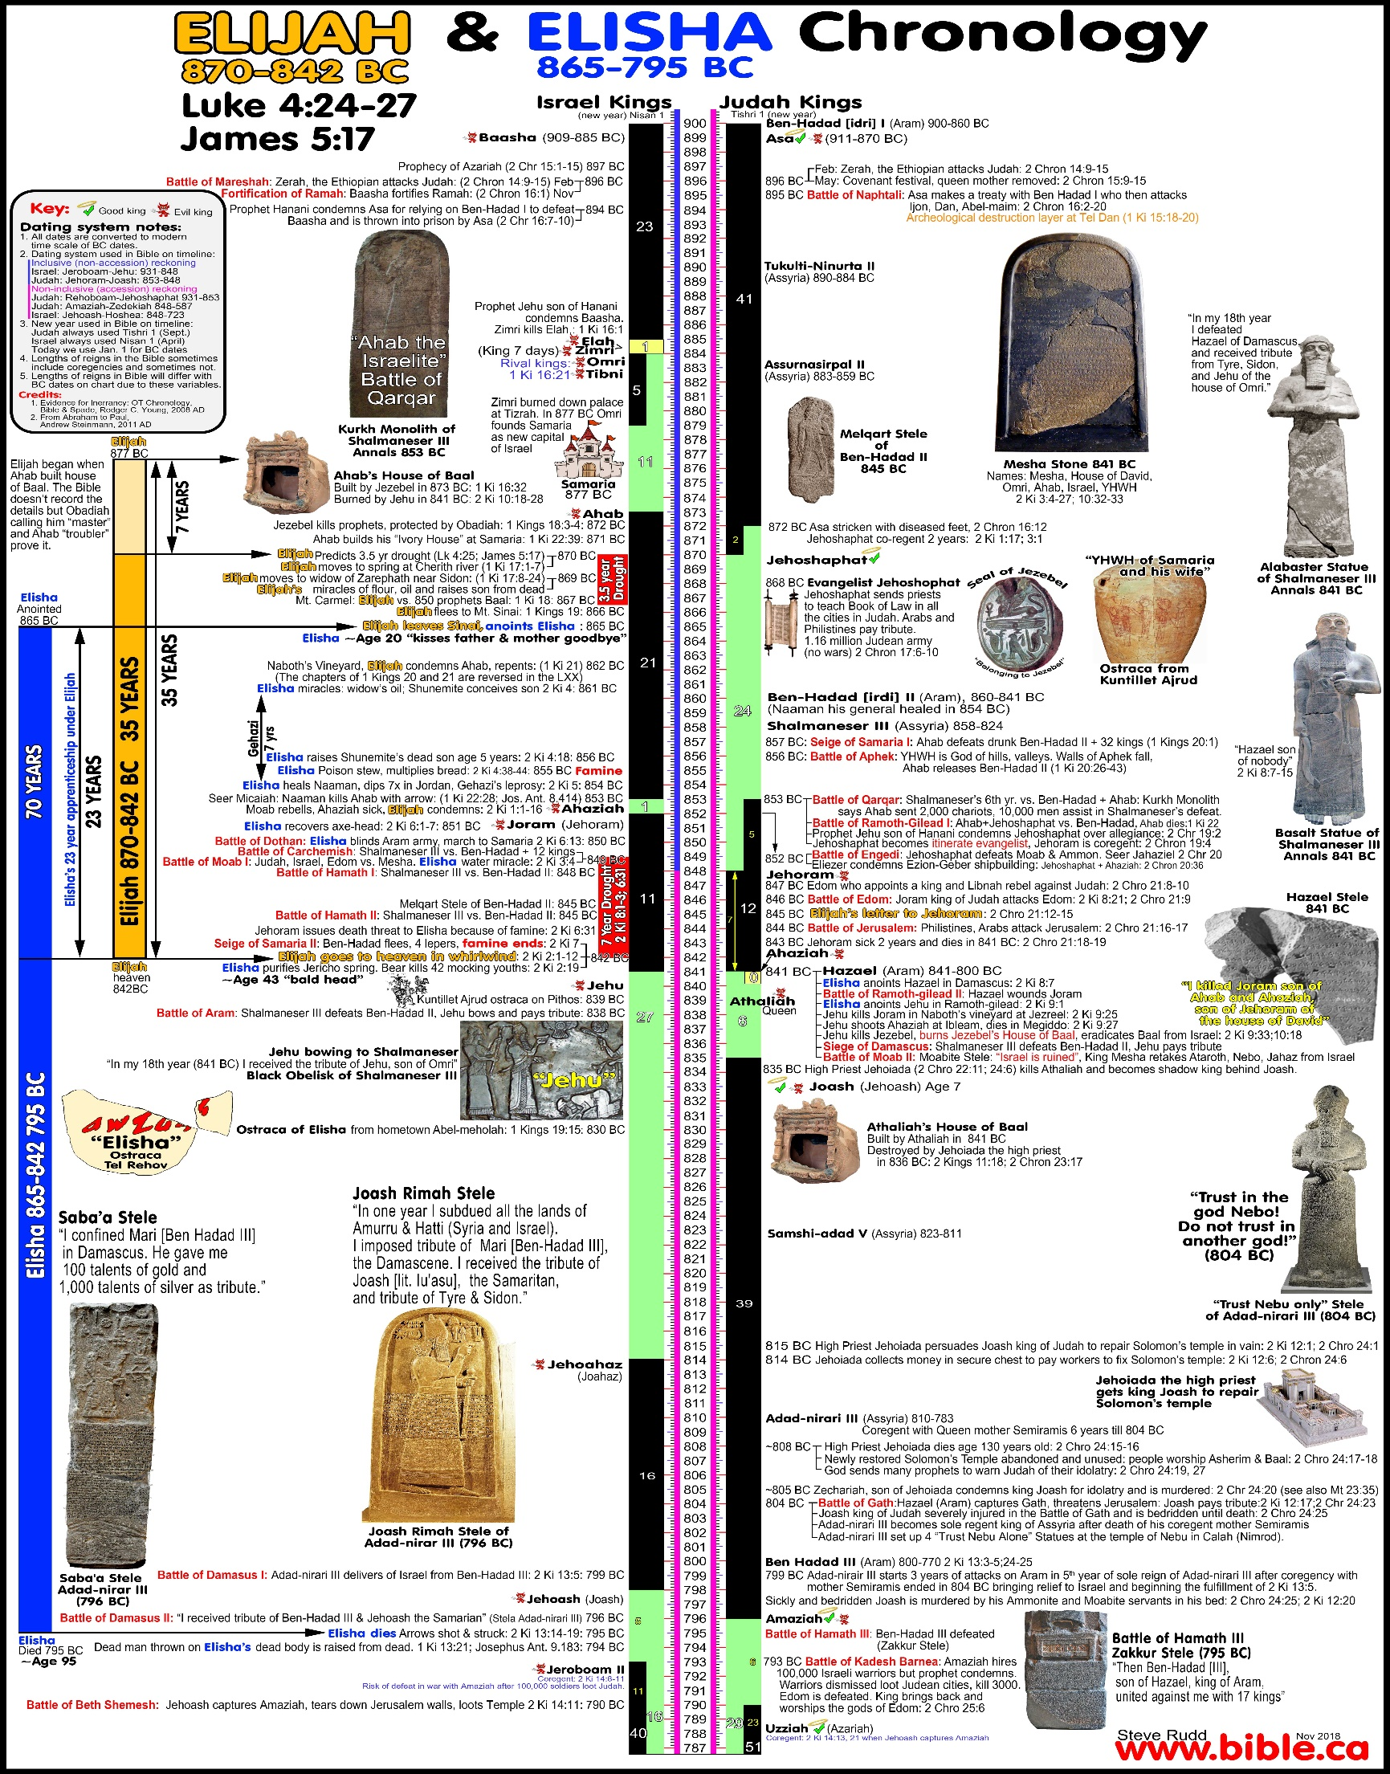](https://www.bible.ca/chronology/bible-chronology-timeline-Elijah-Elisha-John-the-Baptist-Jesus-types-antitypes-870-810BC.jpg)