**Variants in Daniel: MT vs. LXX**

**70 weeks of Daniel 9:24**

**70 weeks | Susanna | Prayer of Hananiah | Bel and the dragon**

[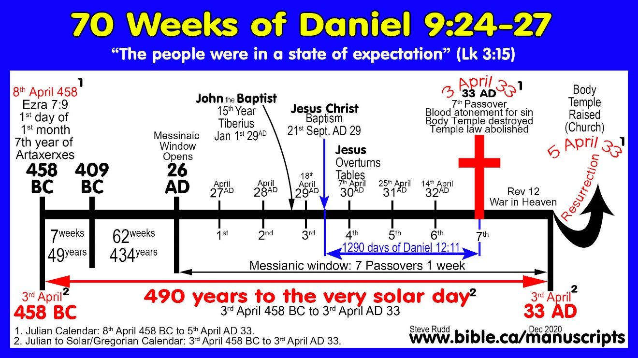](https://www.bible.ca/bible-chronology-chart-70-weeks-Daniel9.24-Messiah-490-years-7th-year-Artaxerxes-458BC-resurrection-33AD.jpg)

**70 Weeks are 490 years to the solar day from 8th April 458 BC to 5th April AD 33 (Julian)**

1. The 70 weeks = 7 x 70= 490 years
   1. It started with the decree to rebuild Jerusalem in (Ezra 7:9) on 1 Nisan, 7th year of Artaxerxes which we know was 8th April 458 BC.
   2. Ended at the resurrection of Christ in 5th April 33 AD.
2. Jesus the Messiah rose from the dead 490 solar years to the very day Artaxerxes issued his decree:
   1. The decree to rebuild Jerusalem in Ezra 7:7-26 records Ezra departing Babylon for Jerusalem on 1st Nisan (first month in Jewish Calendar) in the 7th year of Artaxerxes in 458 BC which translates to 8th April 458 BC (Julian calendar) and to 3rd April 458 BC (Solar/Gregorian Calendar).
   2. The resurrection of Jesus was on 16th Nisan 33 AD (Jewish Calendar) which translates to 5th April 33 AD (Julian calendar) and to 3rd April AD 33 (Solar/Gregorian Calendar).
   3. The solar calendar (Gregorian Calendar) is God’s Calendar for a year because it is the exact time it takes the earth to orbit the Sun.
   4. Today we use the Julian Calendar which requires leap years to keep it is in sync with God’s solar calendar. The 490 years of Daniel’s 70 weeks is exactly 490 solar years to the very day.
3. Hebrew, Julian, Gregorian conversion equivalents:

|  |  |  |  |
| --- | --- | --- | --- |
| **Daniel 9 computes 490 solar years to the day ending in the resurrection** | | | |
|  | Calendar conversion equivalents | | |
| Daniel 9:24 | Hebrew calendar | Julian calendar | Gregorian/solar calendar |
| 70 weeks start: Decree: Ezra 7:9 | 1st Nisan 458 BC | 8th April 458 BC | 3rd April 458 BC |
| 70 weeks end: Resurrection | 16th Nisan AD 33 | 5th April AD 33 | 3rd April AD 33 |

1. The year in the Gregorian calendar is 365.2425 mean solar days long. “This approximation has an error of about one day per 3,030 years”
2. Scientific calculations of 490 Solar/Gregorian years from 8th April 458 BC to 5th April AD 33 (Julian)
   1. **1 Mean Tropical Solar Year = 365.2421897 days**. 490 years = 178968.672953 days (365.2421897 x 490). Rounded off, there are 178,969 days in a solar year.
   2. **In AD 1849, John F. Herschel created a universal astronomical day count** that he hypothetically began on 1st January 4713 BC as his “day 0” and 4712 BC as his day “1”. His numbering system then counted forward from 4713 BC up to the present. Herschel’s system assigned 8th April 458 BC as day 1,554,236 from 1st 4713 BC, and 5th April AD 33 as day 1,733,206 from 1st 4713 BC. The difference is exactly 178,970 days from 8th April 458 BC to 5th April AD 33 (Day 1,733,206 – day 1,554,236 = 178,970 days).The difference in the calculation between the Mean Tropical Year and Herschel is only 1.33 days. (178970-178968.67 = 1.3 days)

|  |  |  |  |
| --- | --- | --- | --- |
|  | 1st January 4713 BC | 8th April 458 BC | 5th April AD 33 |
| Herschel day | Day 0 | Day 1,554,236 | Day 1,733,206 |
| Days in 490 years | | 178,970 days | |

* 1. All modern scientific calculation methods prove it is exactly 490 solar years (± 1.33 days) for both the Gregorian and Julian calendars between 8th April 458 BC to 5th April AD 33 (Julian) and 3rd April 458 BC to 3rd April AD 33 (Gregorian).

|  |  |
| --- | --- |
|  | Days in 490 Solar years |
| Herschel calculation | 178968.67 days |
| Tropical calculation | 178,970 days |
| Difference | 1.33 days |

1. This proves that from the decree of Ezra 7:9 to the resurrection is exactly 490 years to the solar day.

**Masoretic Text: Cut off in the “Middle” or the “half” of the week: Dan 9:27**

1. Many follow the MT and synchronize the crucifixion with “Cut Off”:
   1. How to interpret the remaining 3 ½ years?
      1. Conversion of Paul?
      2. Conversion of Gentiles in Acts 10, Cornelius
2. Proper translation of: “in the middle [חֲצִי  *hatsi*]of the week he will put a stop to sacrifice and grain offering”.
   1. The Hebrew word “*hatsi*” should be translated “half” not “middle”.
   2. חֲצִי  [*hatsi*] is translated: Half: 76 times, Half-tribe (Ephraim/Manasseh): 33 times, Middle: 6 times, Midnight: 3 times, Midst: 2 times, One-half: 2 times.
3. Bibles that translated “hatsi” as “half” in Dan 9:27:
   1. “Forsothe he shal conferme the couenaunt with manye oo weeke, and in the half of a weeke oost and sacrifice shal fayle” (Wycliffe Bible, Translated from the Latin Vulgate, 1382 to 1395 AD)
   2. “He shall make a stronge bonde with many, for the space of a weke: and when the weke is half gone, he shal put downe the slayne and meatoffringe.” (*The Holy Scriptures,* Myles Coverdale, 1535 AD)
   3. “And he shall confirm the covenant with many, in one week: and in the half of the week the victim and the sacrifice shall fail” (Douay-Rheims Bible, 1609 AD)
   4. “And he made strong the covenant to many one week: and half the week he shall cause the sacrifice and gift to cease” (The Holy Bible, Julia E. Smithtran, 1876 AD)
   5. “And he will make a strong covenant with the many for one week; and in the half of the week will he cause the sacrifice and the oblation to cease” (The Twenty-Four Books of the Holy Scriptures: Carefully Translated according to the Massoretic Text, Isaac Leeser, 1891 AD)
   6. “Now one week shall confirm a covenant for many and in the half of that week my sacrifice and libation shall be taken away.” (The Old Covenant, Translated from the Septuagint, S. F. Pells, 1904 AD)
   7. “And he shall make a firm covenant with many for one week: and for the half of the week he shall cause the sacrifice and the obligation to cease” (American Bible Union Version, American Baptist Publication Society, 4th edition, 1913)
   8. “He shall make a strong covenant with many for one week, and for half of the week he shall make sacrifice and offering cease” (NRSV)
   9. “And he shall make a firm covenant with many for one week: and for the half of the week he shall cause the sacrifice and the oblation to cease” (English Revised Version)
   10. “He will make a binding covenant with many for one week, and for half of the week he will pause both the sacrifice and grain offerings.” (International Standard Version)
   11. “And he will make a strong covenant with the many for one week, but in half of the week he will let cease sacrifice and offering” (The Lexham English Bible)
   12. “He will fortify a covenant with many weeks, for one and at the half of the week my sacrifice and drink-offering will be removed.” (The Lexham English Septuagint)
4. Sacrifice will also stop anytime during the second half of the last week. This could be interpreted two ways, which are both equally true.
   1. **Start of the second half: Jesus body was the perfect sacrifice:** Sacrifice was abolished at the beginning of the second half of the 70th week when Jesus was baptized and was officially anointed as the lamb of God. His body was not only the true Temple, but the True sacrifice of that temple of God. Once Jesus began his ministry, his body became the only true sacrifice, essentially nullifying and obsoleting all other sacrifices. In this interpretation, sacrifice does stop at the exact middle of the last week corresponding to the Baptism of Jesus.

"For it is impossible for the blood of bulls and goats to take away sins. Therefore, when He comes into the world, He says, “SACRIFICE AND OFFERING YOU HAVE NOT DESIRED, BUT A BODY YOU HAVE PREPARED FOR ME; IN WHOLE BURNT OFFERINGS AND sacrifices FOR SIN YOU HAVE TAKEN NO PLEASURE. “THEN I SAID, ‘BEHOLD, I HAVE COME (IN THE SCROLL OF THE BOOK IT IS WRITTEN OF ME) TO DO YOUR WILL, O GOD.’ ”" (Hebrews 10:4–7)

* 1. **End of the second half:** Sacrifice abolished at the cross: Sacrifice was made obsolete, extinct and void when the entire Law of Moses was nailed to the cross: Col 2:14-17; Heb 8:6-7; 8:13-9:4. In this interpretation, sacrifice ceases when the Mosaic Law is nailed to the cross, at which time, the Messiah is cut off at the end of the second half of the last week. This agrees what the Codex Vaticanus (LXX) except for the huge difference that Septuagint says nothing of the Messiah being “cut off” but instead says the “messiah will finish his word at the end of the 70th week.

**Variants between Septuagint Codex Vaticanus vs. Masoretic Text**

|  |  |
| --- | --- |
| **Variants Between Christian LXX and Jewish MT in Daniel 9:24-27** | |
| **Septuagint: Vaticanus (350 AD)** | **Masoretic Text (1008 AD)** |
| **24**Seventy sevens have been decreed upon your people and upon the city, Zion, to complete the guilt and to deal with the unjust offenses and to wipe away the injustices and to fully understand the vision and to establish everlasting righteousness and to complete the visions and the prophet and to delight in the holy of holies. | **24** Seventy weeks have been decreed for your people and your holy city, to finish the transgression, to make an end of sin, to make atonement for iniquity, to bring in everlasting righteousness, to seal up vision and prophecy and to anoint the most holy place. |
| **25**And you will know and understand and rejoice, and you will find commands to respond, and you will build Jerusalem, the city, for the Lord. | **25** “So you are to know and discern that from the issuing of a decree to restore and rebuild Jerusalem until Messiah the Prince there will be seven weeks and sixty-two weeks; it will be built again, with plaza and moat, even in times of distress. |
| **26**And after seven periods of seven and sixty-two *periods of seven*, an anointed place will be removed, and it will not be. And a kingdom from among the nations will despoil the city and the holy place along with the anointed one, and his end will come with destructive anger until the set time of the consummation. There will be war upon war. | **26** “Then after the sixty-two weeks the Messiah will be cut off and have nothing, and the people of the prince who is to come will destroy the city and the sanctuary. And its end will come with a flood; even to the end there will be war; desolations are determined. |
| **27**And the covenant will be made strong for many, and it will recover again, and it will be built up in breadth and length. And at the end of the appointed times, and after seven periods of seventy appointed times and sixty-two years during the set time of the consummation of war, then the desolation will be taken away when the covenant prevails for many weeks. And at the completion of the period of seven, offering and drink-offering will be taken away, and upon the holy place there will be an abomination of desolation until the end. And a determined final destruction will be rendered upon the one making desolate.”  (Daniel 9:24–27, LXX, Vaticanus) | **27** “And he will make a firm covenant with the many for one week, but in the middle of the week he will put a stop to sacrifice and grain offering; and on the wing of abominations will come one who makes desolate, even until a complete destruction, one that is decreed, is poured out on the one who makes desolate.”" (Daniel 9:24–27, MT) |

**Septuagint Text:**

1. Messiah is never “Cut off”, much less cut off in the middle of the last week.
2. Instead the messiah completes his word by the end of the last week

Steven Rudd

3 November 2021