What is the Bible?
- The bible is a unified message: Paradise lost in Genesis is Paradise regained in Revelation
- The Bible contains a single unified message from Genesis to Revelation found in a collection of 66 books and letters written by 40 men in three languages (Hebrew, Aramaic, Greek) on 3 continents, over a period of about 1600 years (1446 BC – AD 102).  - The unity of the Bible is a powerful argument for divine inspiration because even a small group of men can rarely come to any degree of unity on even one topic. | 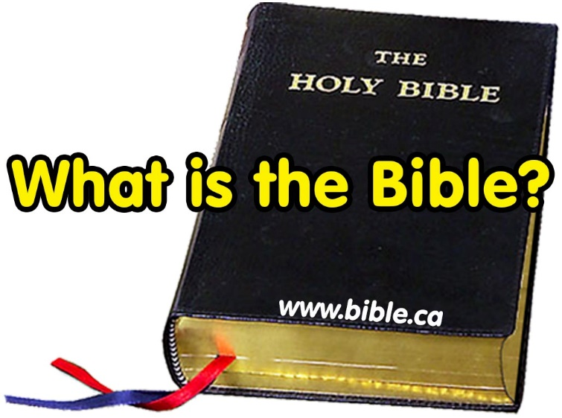
  - Even a small group of friends rarely agree on any subject. The unity found in the Bible is vastly superior to the sacred writings of all other world religions. Anyone who has ever studied these writings must admit they are jumbles of disjointed material, without order, continuity or unity of any kind. The 66 books of the Bible on the other hand, weave a unified message from Genesis to Revelation.
- The Bible is God’s only direct message of salvation to man on earth: 2 Tim 3:16; 1 Thess 2:13
  - No salvation in the Koran of Islam
  - No salvation in the book of Mormon
  - No salvation in the Analects (proverbs) of Confucius
  - No salvation in the Vedas and Upanishads of Hinduism
  - No salvation in the Seven Valleys of Bahai
  - No salvation in the Tanakh (Old Testament) of Judaism
  - No salvation in the Book of Shadows of Wicca
  - No salvation in the Da Vinci Code, Harry Potter, Lord of the Rings, Pride & Prejudice.
- The Bible is the message of the Holy Spirit filtered through human personalities: Jer 1:9; 2 Pet 1:20-21; Jn 16:12-13
  - Man was the pen in the hand of God, but just as each pen produces distinctive script, so too each man expresses the will of the God in his own unique way.
  - The personality of each Bible writer is so clear, we can identify Bible texts as the “Pauline style” (Paul), “Petrine style” (Peter), “Lucian style” (Luke).
- The Bible is God’s blueprint for morality and doctrine: Heb 8:4·5; Rom 6: 17; 2 Pet 1 :3-4
  - Beware you do not deviate from the Bible blueprint: Lev 10:1-3
- The bible is our manufacturers repair guide-book: Hebrews 12:11–13
- The Bible is a book of scientific foreknowledge: Ps 8:8
  - “At one time, when Commodore Maury was very sick, he asked one of his daughters to get the Bible and read to him. She chose Psalm 8, the eighth verse of which speaks of "whatsoever walketh through the paths of the sea," he repeated "the paths of the sea, the paths of the sea, if God says the paths of the sea, they are there, and if I ever get out of this bed I will find them." (back cover comment by Katherine C. Stiles, A Brief Sketch of the Work of Matthew Fontaine Maury, Richard Launcelot Maury, 1915 AD)
  - Upon his recovery, Maury took God at his word and went looking for these paths. We are indebted to his discovery of the warm and cold continental currents. His book on oceanography is still considered a basic text on the subject in universities. Maury used the Bible as a guide to scientific discovery. If only more would use the Bible as a guide in their personal lives!
- The bible is an infallible book of history: “What you read in the Book you find in the ground”.
  - Around AD 1900, skeptics viewed the Bible as myth rather than real world history. For example, the Bible makes over 40 references to the great Hittite Empire. You see, 100 years ago, no archaeological evidence had ever been found to prove it really did exist. "Just another Bible myth!" skeptics charged, to destroy our faith in the Bible. This, however, cannot be said today, for in 1906, Hugo Winckler uncovered a library of 10,000 clay tablets. These ancient records fully documented the long lost Hittite Empire and confirmed the reliability of the Bible. Later excavations uncovered Boghazkoy, the capital city of this "mythical" empire.
  - Today, so many Bible cities, names and events have been unearthed through archaeology that the Bible is considered the single most important historical document in existence. Many lost cities have been located using the Bible as a road map. So startling and impressive are some of the finds that one archaeologist was compelled to say, "They are digging up Bible stories!"
  - If only more would realize that the Bible is not only a guide to the fallen ruins of ancient cities, but also a road map to the glorious city of Heaven!
- The bible is an infallible book of chronology:
  - Using the Septuagint (LXX) we can date the age of the earth to 5554 BC.
  - Based upon Daniel 9:24, Jesus was born in 2 BC, and he was crucified in AD 33.
  - Egyptian Chronology is lost without the Bible Chronology.
- The bible is a book of prophecy:
  - Countless prophecies regarding the rise and fall of nations:
    - Dan 2: Babylon, Persia, Greece, and Rome.
    - Amos, Hosea: destruction of Israel and ten northern tribes: 723 BC
    - Ezekiel 26:3-14: destruction of Tyre by Nebuchadnezzar and Alexander the Great
    - Jeremiah: destruction of Jerusalem in 587 BC
    - Revelation: destruction of Jerusalem in AD 70
  - Messianic prophecy: Deut 18:18; 2 Sam 7:14; Num 24:17; Micah 5:2
  - Prophecy of end of the world:
    - Second coming: Jn 14:6; Heb 9:28
    - Destruction of earth and Judgement: Rev 20:11-12
- The Bible is indestructible without contradictions: Isa 55:11; John 10:35
  - Translations do not change the message.
  - Hebrew was extinct among the Jews since 500 BC. The Jews used a Greek translation of the Hebrew from 282 BC down to AD 70. Jesus and the apostles used the Greek translation.
  - Beware of lies that the Bible has hundreds of documented contradictions. There are zero.
- The Bible is an “unperishable” seed: Luke 8:11; 1 Peter 1:23-25.
  - 2000 year old seed #1: Excavations in the 1960’s in Herod the Great's palace at Masada, Israel, discovered a number of the first century Judean date palm seeds in a storage jar that had been extinct since AD 800. One of the seeds spouted in AD 2005 and the tree was nicknamed “Methuselah”. The male gendered palm has grown to a height of 12 feet in AD 2021 and has been cross fertilized with female palms to propagate the species.
  - 2000 year old seed #2: Scott Stripling discovered seeds in excavations in the 2000’s at Tel el-Hammam that were 2-3000 years old. After collecting samples for storage and research, the rest he put on a ledge. After a rain a few days later, they sprouted.
  - Beware of counterfeit seed: Mt 13:24-30; 1 Ti 4:1-4; Mk 7:6-9; Mt 24:11
- The Bible is understandable when we read it without any help from the Holy Spirit: Ps 119:130,105; Eph 3:3-5; Acts 17:11
- The Bible is the basis of our judgement after we die: John 12:48; Rev 20:12

Steven Rudd, June 2021

