**What is the Christian’s hope?**

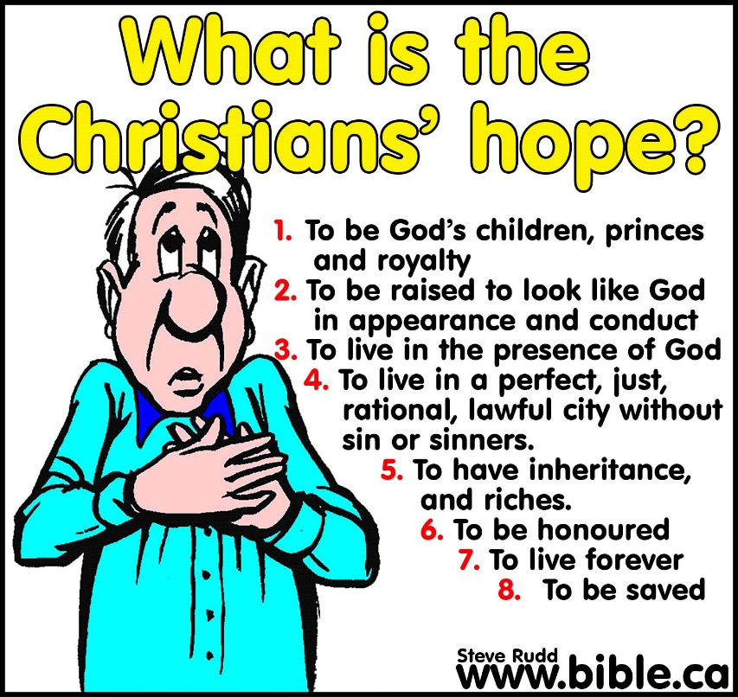

**Introduction:**

1. Hope = desire + expectation
   1. Nobody hopes to eat liver: Wife announces liver for dinner. You expect to eat it but you do not desire it.
   2. Nobody hopes to win the 50 million dollar the lottery: You desire to win but do not expect to.
2. The hope of the godless will suddenly be destroyed: Job 8:11–14; Jas 1:9–11
3. Hope deferred: Prov 13:12

**Lesson:**

1. To be God’s children, princes, and royalty: Jn 1:12–13; 1 Jn 3:1,10; Gal 3:26–29
2. To be raised into powerful, spiritual, and supernatural beings exactly like God in conduct and appearance: 2 Pet 1:3-4; 1 Jn 3:2; Phil 3:20–21; Jn 6:40; Acts 23:6; 24:15; 1 Cor 15; Phil 1:21–24
3. To live in the very presence of God: Heb 6:13-20; Jn 13:36; 2 Cor 4:18
4. To live in a perfect, just, rational, lawful city without sin or sinners:
   1. Inside vs. outside: Rev 22:14–15
   2. Lot and Christians are tormented on earth by sin and corruption: 2 Pet 2:6–8
   3. The world loves evil and hates good: Isaiah 5:20; Micah 3:2,9; 7:2–4; Prov 17:15; Amos 5:7-13; Ps 94:21; Mal 2:17; Jas 5:6
5. To have inheritance, and riches in heaven: 1 Peter 1:3–5; Mt 6:19-20; Mk 10:28–31; Luke 12:13–21
6. To be honoured in heaven: Jn 12:26; 1 Pet 1:7; Rom 2:9–10;
7. To live forever: Mk 10:31; 25:46; Jn 3:14–16; 4:13–14; 5:24; 17:1–3; Rom 2:5–8; Gal 6:8; Tit 1:2; 1 Jn 5:13; Jude 21
8. To be saved: Psalm 119:166

**Conclusion:**

1. Hope is the helmet that protects Christians from hard and injury: 1 Thess 5:8
2. We have a great hope: Rom 8:19–25
3. We need to evangelize our hope: 1 Pet 3:15
4. Hope while living: Once we die our fate is sealed in judgement: Eccl 9:4; Heb 9:27–28

Steven Rudd July 2021